From: Matt DeLorenzo
Subject: Adding a Lime-Yellow Scotchlite to Cairns Fire Helmets
Date: August 16, 2012

To Whom It May Concern:

In reference to your Lime-Yellow Scotchlite (3M 8887) inquiry, you may add said Scotchlite to a Cairns fire helmet without voiding the warranty or affecting the NFPA 1971-2007 certification, as that is an authorized component offered by MSA for Cairns helmets.

If you have any questions or need any additional information, please let me know.

Thank you!

Regards,

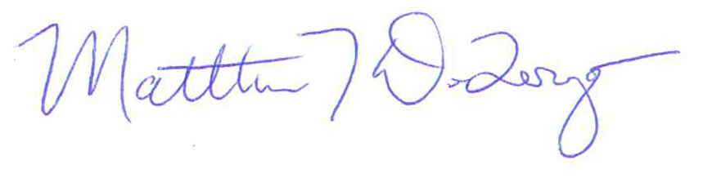

Matt DeLorenzo
Product Line Manager
Cairns Helmets and Communication Systems
MSA North America
(724) 776-7764

